**Interface BlockingQueue<E> Super interface is Queue**

**Methods from Queue interface**

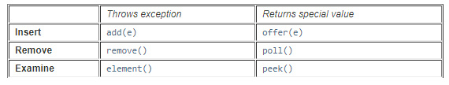

**Methods present in BlockingQueue**

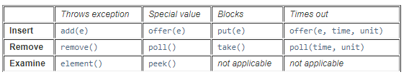

Implementations of **BlockingQueue interface are:**ArrayBlockingQueue

DelayQueue

 LinkedBlockingDeque

LinkedBlockingQueue

 LinkedTransferQueue

 PriorityBlockingQueue

SynchronousQueue

|  |  |
| --- | --- |
| boolean | [**add**](https://docs.oracle.com/javase/7/docs/api/java/util/concurrent/BlockingQueue.html#add(E))([**E**](https://docs.oracle.com/javase/7/docs/api/java/util/concurrent/BlockingQueue.html) e)  Inserts the specified element into this queue if it is possible to do so immediately without violating capacity restrictions, returning trueupon success and throwing an IllegalStateException if no space is currently available. |
| boolean | [**remove**](https://docs.oracle.com/javase/7/docs/api/java/util/concurrent/BlockingQueue.html#remove(java.lang.Object))**(**[**Object**](https://docs.oracle.com/javase/7/docs/api/java/lang/Object.html)**o)**  **Removes a single instance of the specified element from this queue, if it is present.** |
| [E](https://docs.oracle.com/javase/7/docs/api/java/util/Queue.html) | [**element**](https://docs.oracle.com/javase/7/docs/api/java/util/Queue.html#element())**()**  **Retrieves, but does not remove, the head of this queue.** |
| boolean | [**offer**](https://docs.oracle.com/javase/7/docs/api/java/util/concurrent/BlockingQueue.html#offer(E))**(**[**E**](https://docs.oracle.com/javase/7/docs/api/java/util/concurrent/BlockingQueue.html)**e)**  **Inserts the specified element into this queue if it is possible to do so immediately without violating capacity restrictions, returning trueupon success and false if no space is currently available.** |